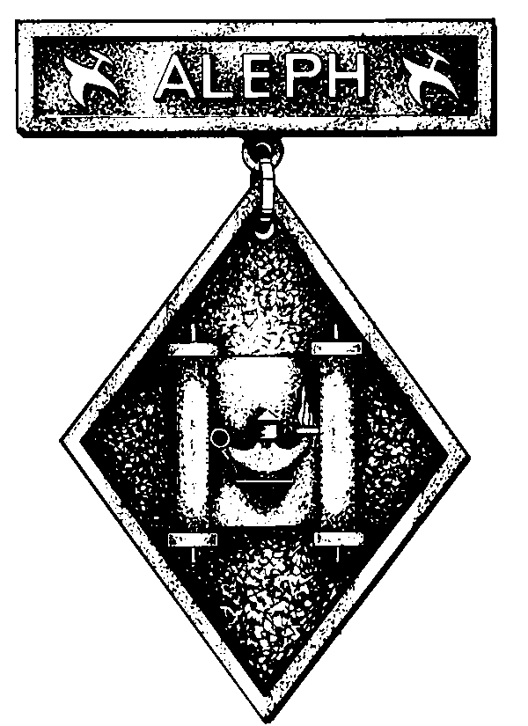

Name: Age: Grade:
Street:
City: State: Zip:

Pack Number: ________ Date Began: __________ Date Completed: __________
ACTIVITIES FOR EARNING THE ALEPH EMBLEM

1. THE TORAH
- Name the five books of the Torah.

- Which of the Ten Commandments do you know best?

Name five of the commandments.
1.
2.
3.
4.
5.

- Tell what these five commandments mean.
1.

2.

3.

4.

5.

- Try to copy one verse of the Torah as it is found in a Torah scroll, or write the meaning of the English verse in your own words.

Mom or Dad sign here:
Date:
2. PRAYER
A. Recite the "Shema" in Hebrew.
B. tell what the words of the "Shema" mean to you.

C. Learn the Hebrew blessings over bread, wine, and fruit.

Mom or Dad sign here:
Date:
3. RELIGIOUS HOLIDAYS
- Give the Hebrew names of six Jewish holidays observed during the year.

- Describe how these six holidays are observed.
1.

2.

3.

4.

5.

6.

- Tell which of the Jewish holidays you like the most, and why.

- On which holidays are the following objects used?

Shofar Spice box
Menorah Cup of Elijah
Haggadah Megillah

Lulav

- Draw or paint two of these objects or make them out of cardboard, wood, or metal.

Mom or Dad sign here:
Date:
4. BIBLE HERO
- Tell the story of two of these Bible heroes: Noah, Abraham, Sarah, Isaac, Rebekah, Jacob, Rachel, Joseph, Moses, Samuel, David, Solomon, Deborah, or Elijah.
1.

2.

- Tell why you chose these two heroes.

Mom or Dad sign here:
Date:
5. FAMOUS AMERICAN JEWS
Write a brief report on two great American Jews and attach to this packet. Here are a few examples: Asher Levy, Haym Salomon, Francis Salvador, Judah Touro, Uriah P. Levy, Emma Lazarus, Jacob H. Schiff, Louis D. Brandeis, Albert Einstein, Henrietta Szold, and Rebecca Gratz.

Mom or Dad sign here:
Date:

6. THE SYNAGOGUE
- Attend Sabbath services at least twice a month for three months and report on one Torah reading for each month.
- Draw pictures of the Ark and the Ner Tamid in your synagogue and describe what they mean to the Jewish people on separate sheets and attach to the packets.

Mom or Dad sign here:
Date:

7. THE JEWISH HOME
- Which object on the outside of a house or an apartment tells us that Jews live there?
- Draw this object or make it out of wood, plastic, cardboard, or metal.
Mom or Dad sign here:
Date:

8. THE LAND OF ISRAEL
- Read a book, magazine article, or news item about Israel and write a report on it and attach to the packet.

- Tell what you know about two cities or places in Israel and attach to the packet. Examples are: Jerusalem, Tel Aviv, the Negev, Haifa, the Kosel (Western Wall), Masada, Beersheva, and the Galilee.

- Draw the flag of Israel or make it out of construction paper or cloth, and write a paragraph describing its meaning to Jews the world over and attach to the packet.

Mom or Dad sign here:
Date:

