Map Skills: Map of Charlemagne's Empire

Study this map of Charlemagne's empire and then answer the questions below.

Charlemagne's Empire, 814 C.E.

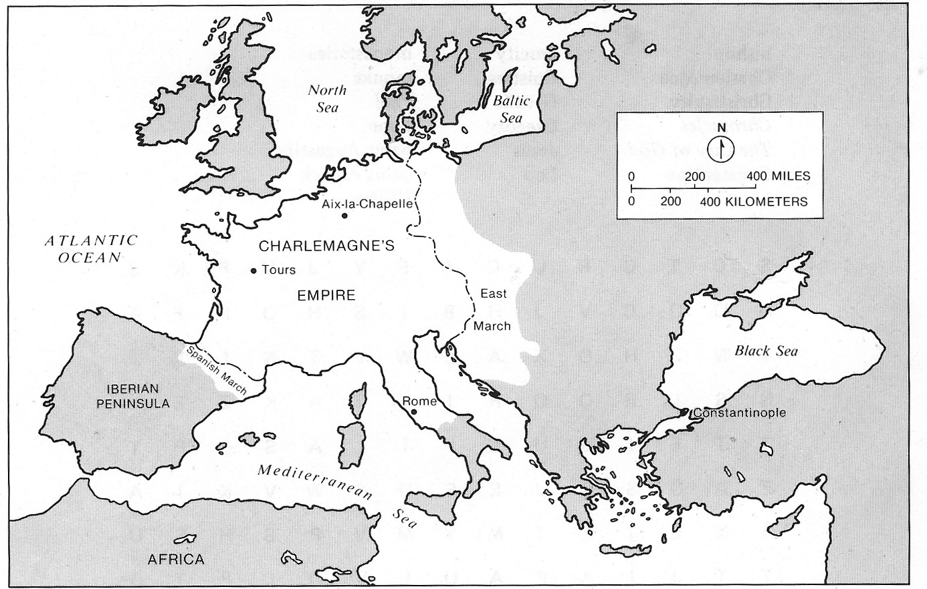

- The northernmost city shown here was Charlemagne's capital. What was it?

- What four bodies of water shown here formed borders of the empire?

- Marches were defense districts. How many marches are shown on this map?
- What names were given to the defense districts?
- About how many miles did Charlemagne travel from his capital to Rome?
- About how many kilometers was it from the northernmost point to the southernmost point of Charlemagne's empire?
- About how many miles was it from the city of Tours to the Spanish March?
- The Spanish March lay between the empire and what area of land?

